

**General Sir John Kotelawala Defence University**

Faculty of Engineering

Department of IT

**Smart Vehicle Parking Management System Enable with Infrared Technology**

Proposal of the Software Engineering Project undertaken in partial fulfillment of the requirements for the Bachelor of ICT Degree program

By

**GGYU Gunasekara**

**ICT/12/0142**

Under the Supervision of

**Mr. ADAI Gunasekara**

**Table of Contents**

**1.0 Introduction4**

1.1 Statement of Parking Lot Problems 4

**2.0 Application Proposal 6**

2.1 Functional Requirements 6

2.2 Non-functional Requirements 7

2.3 Technical Requirements 8

2.4 Usability Requirements 8

2.5 Overview of the System Architecture 9

**3.0 Significance of the Project10**

**4.0 Aim and Objectives10**

**5.0 Scope & Constraints11**

**6.0 Research Approach 12**

6.1 Selection of Research Methodology 12

6.2 Primary Data Spotlight and Actors 12

6.3 Research Design 13

6.4 Ethical Overview 14

**7.0 Summary14**

**8.0 Project Plan15**

**References 16**

**Bibliography17**

**Table of Figures**

Figure 1.1: Improper Parking5

Figure 2.1: System Architectural Design 9

Figure 6.1: Research Design 13

Figure 8.1: Project Plan 15

**Abbreviations**

**IR**- Infrared

**SVPMS** – Smart Vehicle Parking Management System

**SMS**- Short Message Service

**LED**- Light Emitting Diode

**WTC**- World Trade Center

1. **Introduction**

When visiting a new place for the first time or going to an event one must often deal with finding a car parking space. This can be a challenging and frustrating task for number of reasons. In most cases, location of parking spots is not known beforehand. Parking spaces can also have restrictions attached to them. Some parking lots are available only during certain hours of the day or it may only allow parking by people with permits. Most of the parking areas today in Sri Lanka currently operate without any computerized system. They usually require vehicle owners to walk around and manually check the occupancy of individual spots. The owners are concerned that they are not maximizing profit due the inefficient managements of parking spots. In world context, most of the car parks are already monitor occupancy using various technologies that keeps a count of how many vehicles enter and leave the park. This implementation increases the automation and efficiency.

Time and cost are two important factors of human life, whether for an individual or a business. As quality of life increases, more and more people are dwelling cities. Urban life necessitates centralized public facilities. Shopping complexes are an important point of interest both for a city’s residents as well as for visitors. With the emergence of modern shopping complexes which provide a variety of services, more and more people are attracted to visit them. Hence, more shop owners prefer to locate their business in shopping complexes to target more customers and increase revenue (Fishbein & Ajzen 1975).

Recently, shopping complexes have begun providing services much more diverse than just pure selling and buying. Customers can use banking services, post offices, food courts,   
cinemas, children's play areas, and so on. The growth of shopping malls has influenced  
shopping culture and behavior. For instance, in Malaysia window-shopping, or visiting  
shopping complexes simply for looking rather than buying, is a common activity (Coopers 2005). Providing sufficient parking for visitors is one of the main issues in developing shopping complexes. Offering safe and secure parking lots with a sufficient number of spaces and paying attention to handicapped drivers are a few of the factors which can increase customer loyalty and attract customers to visit a shopping mall more frequently.

Parking problems are becoming ubiquitous and ever growing at an alarming rate in every major city. Lot of research and development is being done all over the world to implement better and smarter parking management mechanisms.

* 1. **Statement of Parking Lot Problems**
* Difficulty in Finding Vacant Spaces

Quickly finding a vacant space in a multilevel parking lot is difficult. According to Kianpisheh et al., (2011) 86% of drivers face difficulty in finding a parking space in multilevel parking lots. Finding spaces during weekends or public holidays can take more than 10 minutes for about 66% of visitors. Arenas or shopping malls are crowded at peak periods and difficulty in finding vacant slots at these places is a major problem for customers. Insufficient car park spaces lead to traffic congestion and driver frustration.

* Improper Parking

Improper parking can happen when a driver is not careful about another driver’s rights. Sometimes improper parking occurs when a driver parks on or a bit outside of the lines of a parking space. Figure 1.1 presents an improper parking situation.

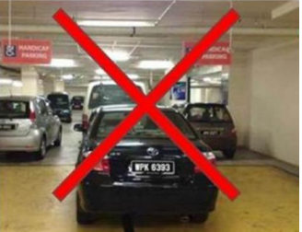

Figure 1.1: Improper Parking

* Poor Management

Poor management about parking availability in areas of high demand lead to large amount of traffic circulating looking for a parking space, contributing to congestion and pollution.

1. **Application Proposal**

In view of above mentioned problems the proposed solution is to develop an automated vehicle parking management system using wireless sensor technology for a shopping complex. Infrared sensors (IR) are used as the wireless sensor technology to detect the entering and leaving of the vehicle. The system will be built as a desktop application with the use of C# under Visual Basic .Net platform for the effectiveness and convenience to the user. The main users of the system will be customers, administrative staff and system operators. Through the approval of the administrator access levels will be granted. Allowing to the access levels the different users can access different portions in the system. The proposed solution will be helped to fulfill parking difficulties and would upsurge the customers’ satisfaction. Each time when a new customer joined the system will automatically update the details. Time to search a parking slot will be diminished.

**2.1 Functional Requirements**

This section contains the functional requirements required of the SVPMS. The requirements in this section specify the functions that each module must be capable of performing.

* Module-1: User Interaction

This module supports the registration of new customers. There are two types of customers.

* Registered Customers
* The SVPMS shall be able to create customer profiles by filling customer details such as first name, last name, date of birth, phone number, company details etc. To log into an account, the user must be able to provide his or her username and password.
* User should be able to edit or delete an account.
* Unregistered Customers - Do not have an online account.
* Module-2: Parking Space Monitoring

Each parking spot has a record of its current state in the database: “available,” “reserved,” or “occupied.”

* The SVPMS shall be able to detect when and if each individual parking space is occupied (in 30 second increments) and be able to report this information to the entrance office.
* The SVPMS shall be able to detect when and if each individual parking space is unoccupied (in 30 second increments) and be able to report this information to the entrance office.
* The SVPMS shall be able to detect when and if each individual parking space is reserved (in 30 second increments) and be able to report this information to the entrance office.
* Module-3: Payments
* The system shall process payments based on length of parking time.
* Periodically (e.g., once a month), the system examines the list of transactions for all customers and generates the monthly statement.
* Module-4: System Administration
* View the registered customers’ profiles and customer statistics.
* Set the various prices and rates for the different services provided.
* Module 5: Statistical Data Collection (Reporting)
* The SVPMS shall be able to display and print reports of the data stored on the network based on user specified criteria.
* The SVPMS should be able to view various statistical charts about parking occupancy over different periods (day, week, month, etc.)
  1. **Non-functional Requirements**

This section point out the non-functional requirements required of the Smart Vehicle Parking Management System (SVPMS).

* Performance requirements

This section specifies the performance requirements that the SVPMS must adhere to.

* The SVPMS shall be able to Perform under any condition
* The SVPMS shall be able to provide continuous updating of every parking space monitored on a 30 second cycle
* The SVPMS shall be able to provide the user with the information that contains the most recent updates of the parking spaces
* Reliability

This section specifies the reliability requirements imposed upon the SVPMS.

* Reliability is defined as providing the user up to date, correct information when they need it. Information is considered correct when the parking spaces are accurately reported and the information is no more than 30 seconds old

# Maintainability

This section specifies the maintainability requirements imposed upon the SVPMS.

* The SVPMS shall not need more than 3 hours of weekly maintenance
* The SVPMS shall not need more than 7 days of annual maintenance (system maintenance different from weekly maintenance)
* Safety

This section specifies the safety requirements imposed upon the SVPMS.

* The SVPMS shall be able to provide data backup in case of system crash
* Security

This section states the security requirements that the SVPMS must adhere to.

* The SVPMS shall not be able to provide access to the unregistered persons
* The SVPMS should not be easily breakable

# Environmental

This section specifies the environmental requirements imposed upon the SVPMS.

* The SVPMS shall not cause physical harm to users and non-users
* The SVPMS shall not cause interference to external systems
  1. **Technical Requirements**

Technical requirements for the development of system are as follows.

* The system will be developed using Microsoft Visual Studio 2012 platform using C# language.
* Microsoft Windows Server 2008 will be used as the database to store the data
* Wireless sensor technology and barcode technology will be used to develop the hardware implementation.
* The application package would develop as it is compatible for any computer which runs on windows platform such as Windows 2000, XP, 2007 and 2008
  1. **Usability Requirements**

Following are the usability requirements of the SVPMS.

* Gather information about the different user access levels and how to personalize the user interfaces for each access levels.
* System shall be able to provide user friendly interfaces to the users.
* Design the interfaces according to gathered user requirements
* System should be adopt in Microsoft web and desktop based environments
* Gather requirements using various fact gathering techniques such as interviews, questionnaires, observations, document review etc. to have a broad idea about the system
* If the users are not up to the standards to use the system in an effective way, system developers should conduct training sessions to develop knowledge to use the system without having any trouble
  1. **Overview of the System Architecture**

Overall structure of the main components of SVPMS are illustrated in the architectural design. The total structure based on the Overall system will be split into three layers as application layer, data link layer and presentation layer as follows.



Figure 2.1: System Architectural Design

Source: Author

1. **Significance of the Project**

Most of the current parking systems are all manually operated systems with personnel deployed to handle the parking process. Here the proposed solution recommend an automated parking management system with a combination of IR technology and Barcode Technology in order to provide an enhanced parking. The system keeps track of vehicles entering and exiting the system.

When a vehicle is entering to the car parking the front office shows the available parking slots at that time. After that with the entrance of a vehicle into the available parking slot, IR sensor detects it and send a signal to the front office by saying ‘slot is occupied’. As the same when leaving the vehicle IR sensor detect it and send a signal by saying ‘slot is vacant’.

Regular customers can login to the website and get registered to obtain offers. After registration they will get a unique barcode number via email address or as a sms to the mobile phone by indicating that the registration is successful. Once entering to the parking area registered customer will get a card with the barcode number. With the aid of barcode reader it will read the barcode number and display the profile. Separate barcode numbering card will be generated for unregistered customer. Entering time and leaving time calculates the total payment.

1. **Aim and Objectives**

Following are the aim and objectives of the proposed solution.

Aim: To develop an application for a shopping complex to manage vehicle parking through IR and Barcode technologies to mitigate the constraints which the customers will faced.

Objectives:

* To develop an application which help customers to find a parking slot in an efficient manner
* To detect occupancy status of each individual space in a multilevel parking lot
* To display the number of available spaces at entrance office
* To display different colored LED lights to differentiate between spaces (reserved, occupied or vacant)
* To provide accurate results with the application to the users
* To provide the application with a user interactive and user friendly manner
* To provide backup, recovery and data integrity features to the database
* To provide authentic and authorized features to secure confidential data which can only be viewed by authorized user
* To deliver error free software application to the users

1. **Scope & Constraints**

Following are describes the scope and constraints of the proposed system.

* Scope:

The proposed solution describes five modules and among those the user interaction module will be a web based module to register customers online. Regular customers can online create a profile including their details. After creating the profile they will get a unique barcode number which stored the details of a particular customer.

Except user interaction module, other all modules such as Parking Space Monitoring, Payments, System Administration, and Statistical Data Collection are not compatible with the customers. These modules can be accessed by the system administrator. Parking space monitoring module identifies state of each parking state whether ‘occupied’, ‘reserved’ or ‘vacant’. System administration module focuses on the operations of each module and set prices for the services. Statistical data collection module generate reports regarding the details stored in the database for a different periods.

* Constraints:

When developing the system there will be some constraints that the developer will have to face. In technical perspective the main issue is to develop the hardware implementation using IR sensor technology. There will be hardware issues which can cause to the output of the system. And also lack of the staff about the IR technology and other stuffs can be occur frequently with the time. Developing with C# and Windows server 2008 there will be some technical issues due to the knowledge of the developer.

As the financial perspective when developing the hardware implementation IR sensors and other related tools should have to purchase and it need to be at manageable cost to the developer. In ethical perspectives when gathering the relevant information it is needed to guarantee the confidentiality of data. Time constraint may be critical due to the gathering requirements, data analysis etc. which runs a lengthy time.

**6.0 Research Approach**

This section illustrates the main actors who involve with the system, perspectives of collecting information, data sources and how the system tally with the agile approach.

**6.1 Selection of Research Methodology**

A combination of qualitative and quantitative methodologies will be used as the data gathering techniques. Due to the quantitative characteristics, quantitative methods will be used and due to some qualitative characteristics, qualitative methods will be used in the project.

**6.2 Primary Data Spotlight and Actors**

Primary data should be gathered from the World Trade Center (WTC) of Sri Lanka to identify the relevance of the vehicle parking management. Primary data are the basic details which will be used to develop the application such as users, process, access levels etc.

The actors or the involving parties will be the administrative staff of the vehicle parking management system, customers and system operators.

**6.3 Research Design**

Research design illustrates how the agile software development help to monitor and analyze the development of an application.



Figure 6.1: Research Design

Source: Author

The initial planning and analysis is kept to a very high level, just enough to outline the scope of the project. Then the developer go through a series of iterations, analyzing, designing, developing and testing each feature in turn within the iterations.

**6.4 Ethical Overview**

Developer of the system assured to safeguard the data which are confidential and never donate the data of the system to anyone who will stand in inside or outside the organization. When gathering information the staff of the WTC will not be influenced by the developer. When accessing information the rights and the freedom of actors will be protected.

**7.0 Summary**

The number of people using their own vehicles has increased exponentially in the past ten or fifteen years. The vehicle parking has become an enormous matter especially in urban areas. In view of increasing vehicle quantity, the proposed solution introduces a smart vehicle parking management system based on IR technology which makes parking much easier for drivers. The system has several advantages such as high efficiency, low cost, high security etc. SVPMS solves all the issues related to vehicle parking such as finding free parking slots, improved demand system and certainly the security issues. So the main objective of this project is to implement a system to find parking slots in great efficient manner. And in the Sri Lankan context vehicle parking management is conducted in the manually file base approach. Due to the difficulty of data handling process the proposed system will give a better solution for the all processing data which is integrate through a central server based database.

In this document it has been included all the information of the background of project, its significance, system architecture and the project scope and constraints. Therefore this document gives an overall idea on the problems as well as the art of solution that mitigate the problem.

**8.0 Project Plan**

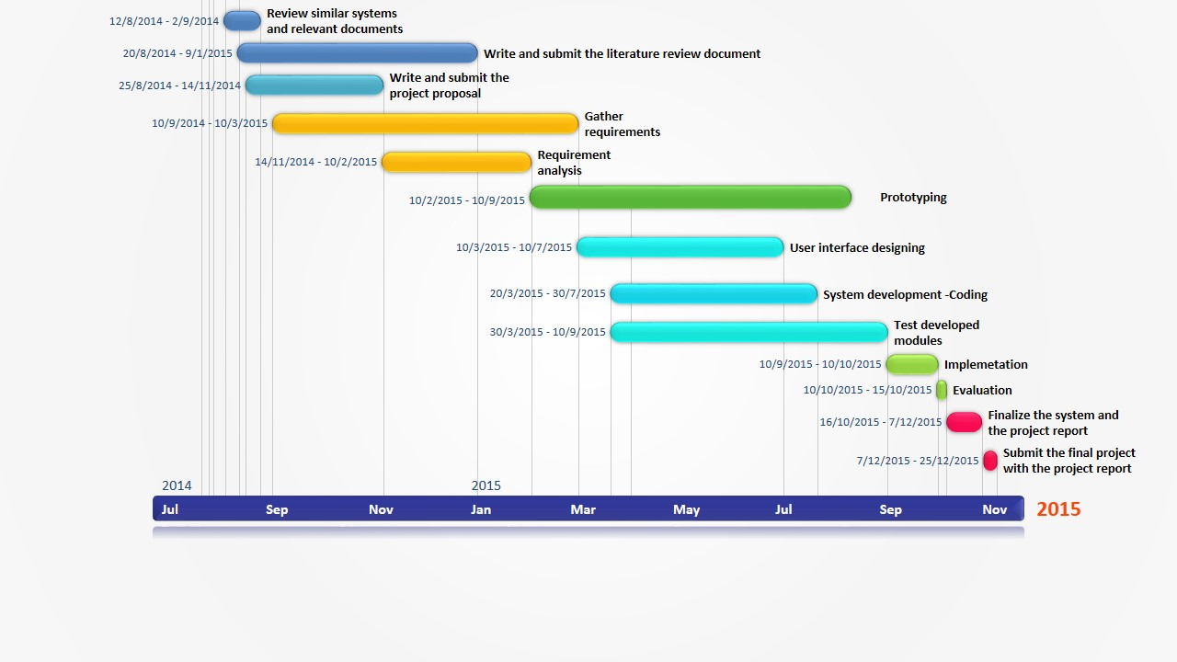

Figure 8.1: Project Plan

Source: Author

**References**

Fishbein, M, Ajzen, I, 1975, “Belief, Attitude, Intention and Behaviour: An Introduction to Theory and Research”

Coopers, P, 2005, “From Beijing to Budapest - Winning Brands. Winning Formats”, pp. 126

Kianpisheh, A, Mustaffa, N, See, J, Keikhosrokiani, P, 2011, “User Behavioral Intention toward Using Smart Parking System”, Proceeding of ICIEIS,Kuala Lumpur, Malaysia, pp. 732-747

Kianpisheh, A, Mustaffa, N, Limtrairut, P, Keikhosrokiani, P, 2012, Smart Parking System (SPS) Architecture Using Ultrasonic Detector,vol.6, no.3, University Sains Malaysia.

Waraich, B, 2012, ‘RFID-Based Automatic Vehicle Parking System’,

<http://www.efymag.com>

Khan, R, Shah, Y, Khan, Z, Ahmed, K, Manzoor M, Ali, A, 2013, Intelligent Car Parking Management System On FPGA, Vol. 10, Issue 1, no.3, Sarhad University of Science and IT, Peshawar, Pakistan, Institute of Business & Management Sciences, AU, Peshawar, Pakistan, UET, Peshawar, Pakistan

Zhang, Z, Li, X, Yuan, H, Yu, F, 2013, A Street Parking System Using Wireless Sensor Networks, vol.2013, Dongguan University of Technology, China

<http://www.hindawi.com/journals/ijdsn/2013/107975/>

Rashid, M, Nusa, A, Rahman, A, Farahana, N, Farhana, A, 2012, Automatic Parking Management System and Parking Fee Collection Based on Number Plate Recognition, International Journal of Machine Learning and Computing, Vol. 2, No. 2

Kastrinaki, V, Zervakis, M, Kalaitzakis, K, 2003, A survey of video processing techniques for traffic applications. Image Vision Comput., 21: 359-381

<http://www.barcodesinc.com/articles/barcode-technology.htm>

**Bibliography**

Bong, D,Ting, K, Rajaee, N, 2006, Car-park occupancy information system. Third Real-Time Technology and Applications Symposium, RENTAS 2006, Serdang, Selangor, December 2006.

<http://www.cs.ieeemalaysia.org/RENTAS2006/papers/Car-Park-Occupancy.pdf>

Funck, S, Mohler, N, Oertel, W, 2004, Determining car-park occupancy from single images. Proceedings of the Intelligent Vehicles Symposium, June 14-17, 2004, Dresden, Germany, pp: 325-328.

Idris, M,Yong, Tamil, L, Haron, Z, 2008, Parking guidance system using RFID and image processing techniques in WSN environment. Proceedings of the 4th International Colloquium on Signal Processing and its Applications, March 7-9, 2008, Royale Bintang Hotel, Kuala Lumpur, pp: 1-6.

Lee, S., Yoon, D, Ghosh, A, 2008, Intelligent parking lot application using wireless sensor networks. Proceedings of the International Symposium on Collaborative Technologies and Systems, May 19-23, 2008, Irvine, CA. pp: 48-57.

Benson, J, O'Donovan, T, O'Sullivan, P, Roedig, U, Sreenan, C *et al*., 2006. Car park management using wireless sensor networks. Proceedings of the 31st Conference on Local Computer Networks, November 14-16, 2006, Tampa, FL., USA, pp: 588-595,

<http://ieeexplore.ieee.org/xpl/login.jsp?tp=&arnumber=4116625&url=http%3A%2F%2Fieeexplore.ieee.org%2Fxpls%2Fabs_all.jsp%3Farnumber%3D4116625>

Chen, M, Chang, T, “A Parking guidance & Information system based on Wireless Sensor Networks”, IEEE International Conference on information & Automation Shenzhen, China, June 2011,

<http://www.ijetae.com/files/Volume4Issue2/IJETAE_0214_95.pdf>

Cheung, Y, Varaiya, P, “Traffic surveillance by wireless sensor networks: final report,” Tech. Rep., California PATH, University of California, Berkeley, Calif, USA, 2007,

<http://www.its.berkeley.edu/publications/UCB/.../UCB-ITS-PRR-2007-4.pdf>

Srikanth, V, Pramod, P, Dileep, K, Tapas, S, Patil, M, “Design & Implementation of a Prototype Smart Parking(SPARK) System using Wireless Sensor Networks” International Conference on Advanced Information Networking & Applications workshops, 978-0-7695-3639-2/09, 2009 IEEE,

<http://ieeexplore.ieee.org/xpl/login.jsp?tp=&arnumber=5136681&url=http%3A%2F%2Fieeexplore.ieee.org%2Fiel5%2F5136571%2F5136572%2F05136681.pdf%3Farnumber%3D5136681>